H.T No
Regulations:
A14

Sreenidhi Institute of Science and Technology
(An Autonomous Institution)
Code No: 4AC41 Date: 06-Feb-2024 (FN)

B.Tech II-Year I- Semester External Examination, Jan/Feb-2024 (Supplementary)
Basic Electrical Engineering (ME, CSE and IT)

Time: 3 Hours Max.Marks:70

Note: a) No additional answer sheets will be provided.
b) All sub-parts of a question must be answered at one place only, otherwise it will not be valued.
c) Missing data can be assumed suitably.

Bloom's Cognitive Levels of Learning (BCLL)

Remember | L1 | Apply | L3 | Evaluate | L5
Understand | L2 | Analyze | L4 | Create | L6

Part - A Max.Marks:20
Answer all QUESTIONS

 |  | BCLL | CO(s) | Marks
1 | If 3 resistors of R ohms are connected in parallel. Find its equivalent resistance. | L2 | CO1 | [2M]
2 | What is the difference between Self and Mutual Inductances? | L2 | CO2 | [2M]
3 | Write the equation for the torque developed in DC motor. | L2 | CO3 | [2M]
4 | What are the various losses in transformer? | L1 | CO4 | [2M]
5 | Define Slip and synchronous speed. | L2 | CO5 | [2M]
6 | Name the different torques involved in operation of indicating type instruments. | L2 | CO6 | [2M]
7 | Write the Statement of the Kirchhoff’s laws. | L1 | CO1 | [2M]
8 | Draw the equivalent circuit of 1-Phase Transformer. | L3 | CO4 | [2M]
9 | Define Phase Sequence. | L1 | CO6 | [2M]
10 | Define RMS and Average value. | L2 | CO2 | [2M]
Part – B Max.Marks:50
ANSWER ANY FIVE QUESTIONS. EACH QUESTION CARRIES 10 MARKS.

 |  |  | BCLL | CO(s) | Marks
11. | a) | Find the maximum power delivered to the load resistance by using maximum power transfer theorem.  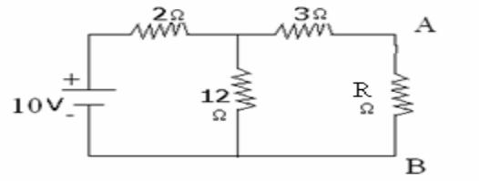 | L3 | CO1 | [5M]
 | b) | Find out current flowing through the 2kΩ resistor using superposition theorem.  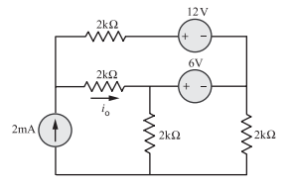 | L3 | CO1 | [5M]
12. | a) | Derive the expression for RMS value of a sinusoidal alternating quantity. | L4 | CO2 | [5M]
 | b) | Show that power in a pure inductor is zero when it is supplied with an AC supply. | L4 | CO2 | [5M]
13. | a) | A 6-pole, wave connected DC shunt motor has 1200 armature conductors. The flux/pole is 22 mWb and it is rotating at 1500 rpm. The armature and shunt field resistances are 0.25 ohms and 110 ohms respectively. Find the supply voltage when its armature takes a current of 25A. | L3 | CO3 | [5M]
 | b) | A 4 pole, Lap connected DC Series generator having 800 conductors supplies a power of 10KW to a load at 200V. The armature and series field resistances are 0.15 ohms and 0.2 ohms respectively. Find the flux under each pole if the machine rotates at 1000 rpm. Neglect Brush drop? | L3 | CO3 | [5M]
14. | a) | Explain the Practical Transformer on load with the help of neat diagram. | L3 | CO4 | [5M]
 | b) | Explain the working principal of a Transformer. | L2 | CO4 | [5M]
15. | a) | Derive the torque equation of 3-Phase Induction motor. | L2 | CO5 | [5M]
 | b) | With Neat Diagram explain the constructional details of 3-phase induction motor. | L2 | CO5 | [5M]
16. | a) | Explain the working principle of MI Instruments. | L2 | CO6 | [5M]
 | b) | Explain different types of damping torques. | L2 | CO6 | [5M]
17. | a) | State and Explain Thevenin’s theorem with an example. | L3 | CO1 | [4M]
 | b) | Define Active power and Reactive power and also write their expressions. | L2 | CO2 | [3M]
 | c) | Derive the torque equation of DC Motor. | L3 | CO3 | [3M]
18. | a) | Why do we conduct OC and SC tests on a Transformer? | L2 | CO4 | [4M]
 | b) | What are the merits and Demerits of slip ring induction motor? | L2 | CO5 | [3M]
 | c) | Differentiate between spring & Gravity control. | L2 | CO6 | [3M]

-- 00 -- 00 –

